Third Lecture
Nitrogen fertilizers or industrial N- fixation
Nitrogen fertilizers play a crucial role in providing essential nutrients to plants, promoting their growth and improving crop yields. However, the reactions of nitrogen fertilizers in soils can have both positive and negative environmental implications.
The primary nitrogen fertilizers used in agriculture include urea, ammonium nitrate, ammonium sulfate, and others.
Here are some key reactions that occur when nitrogen fertilizers are applied to soils:
- Urea Hydrolysis:
  - Urea (CO(NH₂)₂)
  - is a common nitrogen fertilizer. When applied to soil, urea undergoes hydrolysis, a reaction catalyzed by the enzyme urease, which is present in soil microorganisms. The reaction is as follows:

  - CO(NH₂)₂+2H₂O→2NH₄⁺+2HCO₃−CO(NH₂​)₂​+2H₂​ O →2NH₄⁺​+2HCO₃^{−​}

  - This process converts urea into ammonium ions (NH₄⁺) and bicarbonate ions (HCO₃⁻). Ammonium is then available for plant uptake.

- Ammonium Adsorption and Cation Exchange:
  - Ammonium ions released from nitrogen fertilizers are adsorbed onto soil particles.
  - The positively charged ammonium ions (NH4⁺) can undergo cation exchange with other cations (e.g., calcium, magnesium, potassium) on soil particles, making them available for plant roots.

- Nitrification:
Nitrification is
a biological process in soil that involves the conversion of ammonium (NH₄⁺) into nitrite (NO₂⁻) and then further into nitrate (NO₃⁻) by specific groups of soil bacteria.
This process is crucial for the transformation of nitrogen in a form that is more readily available for plant uptake.
The primary stages of nitrification are mediated by different groups of bacteria:
- Ammonium (NH₄⁺) to Nitrite (NO₂⁻):
  - In the first step of nitrification, certain bacteria belonging to the genus
  - Nitrosomonas oxidize ammonium ions (NH₄⁺) to nitrite ions (NO₂⁻).
  - The overall reaction is represented as follows:

  - NH₄⁺→NO₂⁻+2H₂ONH₄⁺​→NO₂⁻​+2H₂​O

- Nitrite (NO₂⁻) to Nitrate (NO₃⁻):

  - The second step involves the oxidation of nitrite ions (NO₂⁻) to nitrate ions (NO₃⁻) by bacteria of the genus Nitrobacter. The reaction can be expressed as:

  - NO₂−→NO₃−+H₂ONO₂−​→NO₃⁻​+H₂​O
Both of these steps are aerobic processes, meaning they occur in the presence of oxygen.
Therefore, nitrification is most active in well-aerated soils with sufficient oxygen levels.
The overall process of nitrification can be summarized as follows:
NH₄⁺ + NO₂⁻→NO₃⁻NH₄⁺ ​→ NO₂⁻​ → NO₃^{−​}
Nitrification is an essential part of the nitrogen cycle and plays a critical role in soil fertility.
Nitrate, the end product of nitrification, is a form of nitrogen that many plants prefer for nutrient
uptake.
However, excessive nitrification can lead to nitrate leaching,
posing environmental concerns such as groundwater contamination.
Management practices that optimize nitrification and minimize nitrogen losses are important for sustainable agriculture.
Denitrification
is a microbial process in soil that involves the reduction of nitrate (NO₃⁻) and nitrite (NO₂⁻) to gaseous forms of nitrogen,
primarily nitrogen gas (N₂) or nitrous oxide (N₂O).
what is the optima conditions encourage (N₂O) formation ?
1- This process occurs in anaerobic (low-oxygen) conditions
2-Is carried out by specific groups of bacteria.
Denitrification acts as a sink for nitrogen in the soil, leading to the loss of nitrogen from the terrestrial ecosystem and returning it to the atmosphere.
What is The primary steps of denitrification ?
include:
- Reduction of Nitrate (NO₃⁻) to Nitrite (NO₂⁻):
  - Certain bacteria first reduce nitrate to nitrite in anaerobic conditions.
  - The reaction is represented as:
  - NO₃⁻→NO₂⁻+gaseous byproductsNO₃⁻​→NO₂⁻​+gaseous byproducts

- Reduction of Nitrite (NO₂⁻) to Nitric Oxide (NO):

  - Nitrite is further reduced to nitric oxide (NO) by denitrifying bacteria:

  - NO2⁻→NO+gaseous byproductsNO2− ​→NO + gaseous by products(منتجات ثانوية )

- Reduction of Nitric Oxide (NO) to Nitrous Oxide (N₂O):

  - Nitric oxide is then reduced to nitrous oxide, which is another greenhouse gas:

  - NO→N₂O+ gaseous byproducts NO→N₂​O + gaseous byproducts

- Reduction of Nitrous Oxide (N₂O) to Nitrogen Gas (N₂):
  - Finally, nitrous oxide can be reduced to nitrogen gas: N2O→N2+gaseous byproductsN2​O→N2​+gaseous byproducts
Denitrification reduces the availability of nitrogen in the soil for plant uptake and returns it to the atmosphere as gaseous forms of nitrogen.
While denitrification is a natural part of the nitrogen cycle, excessive or uncontrolled
denitrification can result in nitrogen loss from agricultural systems, contributing to
environmental issues such as greenhouse gas emissions and nitrogen pollution of water bodies.
Balancing nutrient management practices to minimize nitrogen losses through denitrification is important for sustainable agriculture and environmental conservation.
- Ammonia Volatilization:
- What is the optima conditions to occurs Ammonia Volatilization ?

  - 1- In alkaline soils
  - 2- under high-pH conditions,
  - ammonia (NH₃) can be released into the atmosphere through a process called ammonia volatilization .
  - what is positive or negative effect when Ammonia Volatilization happen ?

  - Negative effect lead to nitrogen loss and reduce the efficiency of nitrogen fertilizer application.
Nitrogen leaching
from soil refers to the process by which nitrogen compounds, particularly nitrate ions (NO₃⁻),
are washed out of the soil and transported through the soil profile by water.
This movement can lead to the loss of nitrogen from the root zone of plants, with potential environmental implications.
What are main factors influencing nitrogen leaching ?
The primary factors influencing nitrogen leaching include soil properties ( pH, texture , Ec, -----) , climate, and agricultural practices( tilth, irrigation , ----) .
How can be leached nitrogen typically ?
- Application of Nitrogen Fertilizers:
  - Nitrogen fertilizers, such as ammonium-based fertilizers, urea, or other nitrogen-containing compounds, are applied to the soil to enhance plant growth.

- Conversion of Ammonium to Nitrate:
  - In the soil,
  - ammonium ions (NH₄⁺) released from fertilizers can undergo nitrification, a process in which soil bacteria convert them to nitrate ions (NO₃⁻). Nitrate is the

  - form of nitrogen that is highly mobile in water.

- Water Movement Through Soil:
  - When water moves through the soil profile due to rainfall, irrigation, or other factors, it carries dissolved nitrate ions along with it.

- Leaching of Nitrate:

  - Nitrate is highly soluble in water and does not bind strongly to soil particles. As a result, it can be easily leached downward through the soil, away from the root zone where plants can take it up.

- Groundwater Contamination:
- )
  - If the leached nitrate reaches the groundwater, it may contaminate groundwater. Elevated ( مرتفعة) nitrate levels in drinking water can have adverse effects on human health, especially for infants, and can also contribute to the contamination of surface water bodies.
Excessive nitrogen leaching
poses several environmental concerns, including water pollution by
Eutrophication of water bodies.(define ?)
Eutrophication is a process that occurs in water bodies, such as lakes, rivers, and coastal areas, where
there is an excessive accumulation of nutrients, primarily nitrogen and phosphorus. These nutrients can come from various sources, including agricultural runoff, industrial discharges, and wastewater.
Eutrophication occurs when nutrient-rich runoff, including nitrogen, promotes the rapid growth of algae in water bodies, leading to oxygen depletion and negative impacts on aquatic ecosystems.
The excessive growth of algae can have several negative impacts on the ecosystem:
Such as :
- Reduced Oxygen Levels:
- As the algae and plants die and decompose, bacteria consume the organic matter, leading to an increased demand for oxygen. This can result in reduced oxygen levels in the water, a phenomenon known as hypoxia or anoxia, which can harm fish and other aquatic organisms that depend on oxygen.
- Fish Kills:
- Low oxygen levels and the decay of organic matter can lead to fish kills and the decline of fish populations in affected water bodies.
- Disruption of Ecosystem Balance:
- Algal blooms can alter the balance of the aquatic ecosystem, negatively affecting other organisms such as zooplankton, insects, and fish.

7-Water Clarity:
8 The excessive growth of algae can decrease water clarity, limiting sunlight penetration and negatively impacting the growth of submerged plants.
Eutrophication is often accelerated by human activities that release large amounts of nutrients into water bodies. Efforts to mitigate eutrophication involve managing nutrient inputs, improving agricultural practices, and implementing wastewater treatment technologies to reduce nutrient loading into water systems.
Farmers and land managers implement various practices to minimize nitrogen leaching, such as using precision nutrient management, for example :
- applying nitrogen fertilizers at the right time.
- using cover crops.
- and adopting conservation practices that reduce soil erosion.
These measures help balance the need for nitrogen in agriculture with the goal of environmental sustainability.

Essentially all N-fertilizers are produced from ammonia gas
There are three methods by which atmospheric elemental N can be converted into chemical Form that can be directly used as a
Chemical fertilizer , these methods or processes are :
- Cyanamide process
Involves passing purified N-gas over calcium carbide at 1100C
CaC₂ + N₂ --------heat------ CaCN₂ + C
CaCN₂ has some toxic effect on crops plants , so application
Recommended 4 to 6 weeks before sowing
CaCN₂ has been used as a herbicide

- Arc Process
Passing N₂ and O₂ through electromagnet as reaction :

N₂ + O₂ ----- 2NO

2NO + O₂ ----- 2NO₂
2NO₂ + H₂O ----- HNO₃ + NO
- Harber – Bosch process
Scientific discovered of early twentieth century , it lead to harber receiving a Nobel prize for this invention ,NH₃ synthesis by the
Main component is magnetite Fe₃O₄ as catalyze and up 1200C
And pressure 200 to 1000 atm. , as below

3 H ₂ + N₂ ---- 2 NH₃

N₂ ----- from atmosphere
H ₂ ------- from nature gas , fuel oil , coal

Anhydrous NH₃ can be reacted with nitric , sulfuric , phosphoric
Acids to make ammonium nitrate , ammonium sulfate and ammonium phosphate can be used as fertilizer

As table 8.7 : general composition of some common N and NP
Fertilizers
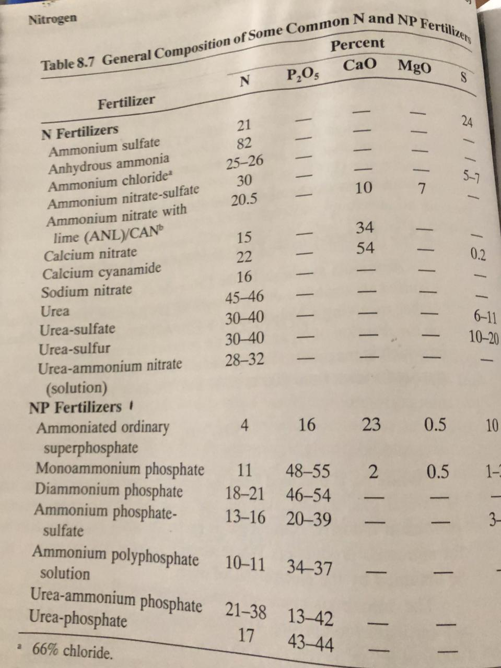
  - Nitrogen management
  - Recovery of N – fertilizer
  - Is calculated as fraction of N – fertilizer applied that is removed in harvested crop , vary from 20% to 80%
  - Depending on crop , amount of N , source of N , soil properties , frequency and amount of precipitation

  - % Recovery = (Ntr. – N co. ) \ N ap. *100

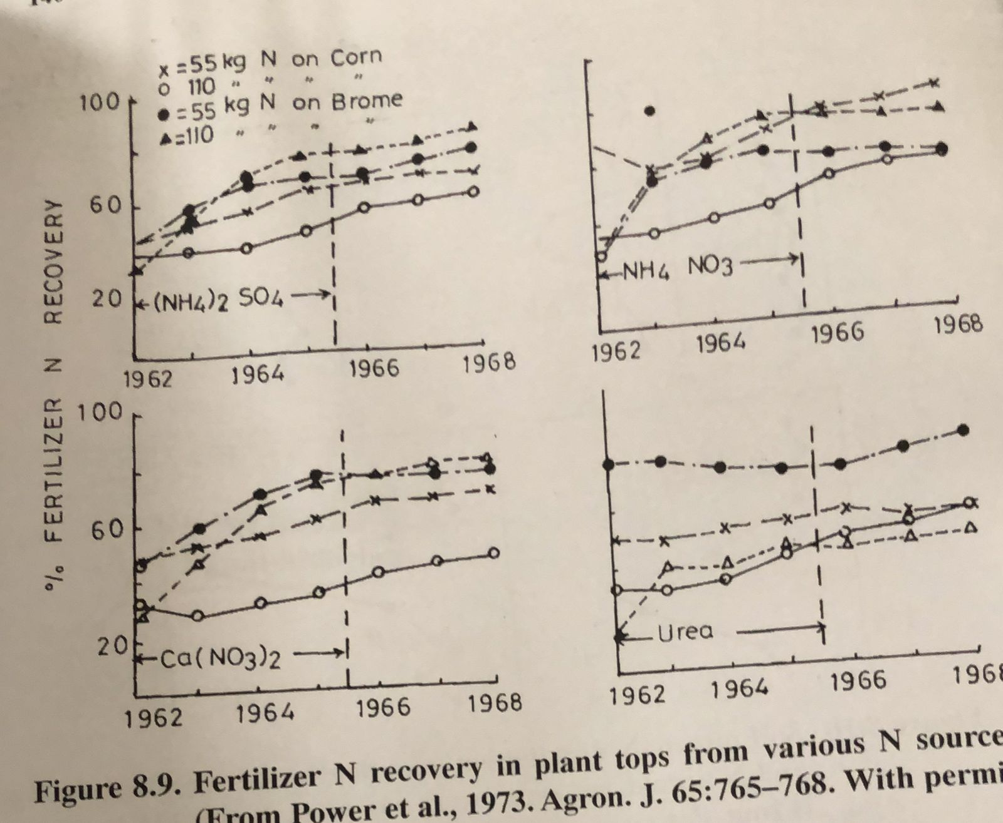

Data showed that N – recovery was greater with bromgrass at 55 than 110 kg h than corn crop due to better system root and biomass
For bromgrass .
(NH4)2SO4 and NH4NO3 were higher than Ca(NO3 )2 may refer to more ammomnia volatilization or leaching of nitrate fig. 8.10

 

